Ideation Phase
Empathize & Discover
Empathy Map Canvas: Educational Organisation Using ServiceNow
 | 30/10/202S
Team ID | NM2025TMID06312
Project Name | Educational Organi5ation using ServiceNow
Maximurn Marks | 100 Marks
The Toot: Empathy Map:
An Empathy Map is Simple, easy-to-digest visual that captures knowledge about a user'S behaviors and attitudes. It helps teams better understand their users and consider things from the user's perspective, including their goals and challenge.
The A High School Teacher
Let^{i}s use the Empathy Map to understand a High School Teacher Who needs support services Oike IT help or ordering textbooks) from the school's new ServiceNow system.
l. understanding the user's world. Il. The Bottom Line pain & Gain
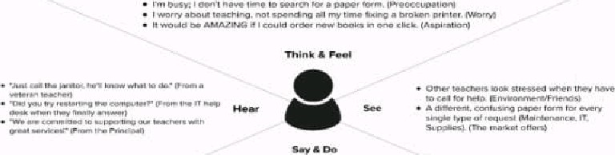
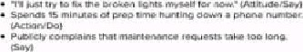
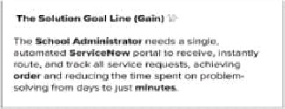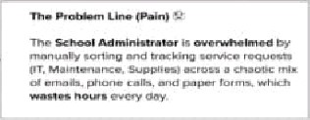

Ref Link:
https•.//a pp. u ra I. co/t/educationalorganisationusing8461/m/educationaIorgan i sa tionu s i ng8461/176 i 821334 070/93ba8f19f7Sd59aa13exa 18fd29416ef27Z26a93 ?sender-u90fcS6cc19405 79346736623
Example: The user: A School Administrator
Develop shared understanding and empathy
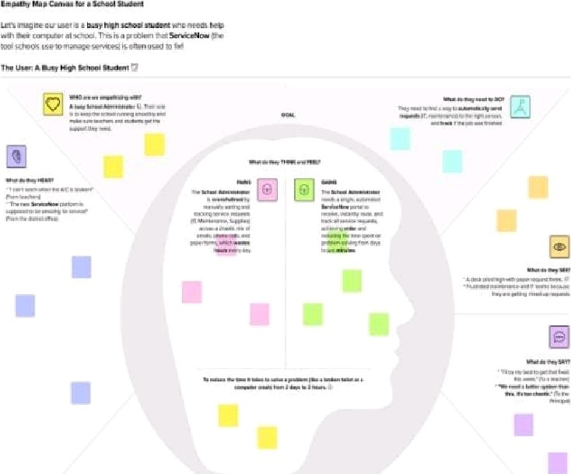
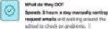
000 | 

